AWS Honeynet – Week 3-6 Observation Reports
Network Traffic Summary

📅 Date
2025-12-15: 00:00AM 2026-1-5: 23:30:00.000AM
Analysis | Figure
Figure 1 maps the frequency of attacks across honeypots during the observation period from December 15, 2025, to January 5, 2026. The histogram reveals three notable spikes in malicious activity: December 17th-18th, December 29th, and January 4th-5th, suggesting that attack patterns are periodic and opportunistic rather than consistent.  The December 17th-18th spike aligns with a broader wave of global cyber activity during that period, which saw accelerating threats across multiple sectors including government and critical infrastructure. The December 29th spike is consistent with well-documented holiday attack trends. Industry data indicates that over half of ransomware attacks occur on weekends or holidays, coinciding with reduced security staffing and slower incident response times. Attackers likely exploited the reduced defensive posture typical of the Christmas-to-New-Year window. Finally, the January 4th-5th spike may reflect a "return from holiday" effect, where the resumption of normal operations created opportunities for attackers to exploit patching backlogs and distracted personnel.  These findings suggest that honeypot exposure is significantly influenced by external threat landscape conditions and seasonal attacker behavior, warranting heightened monitoring during holiday periods. | 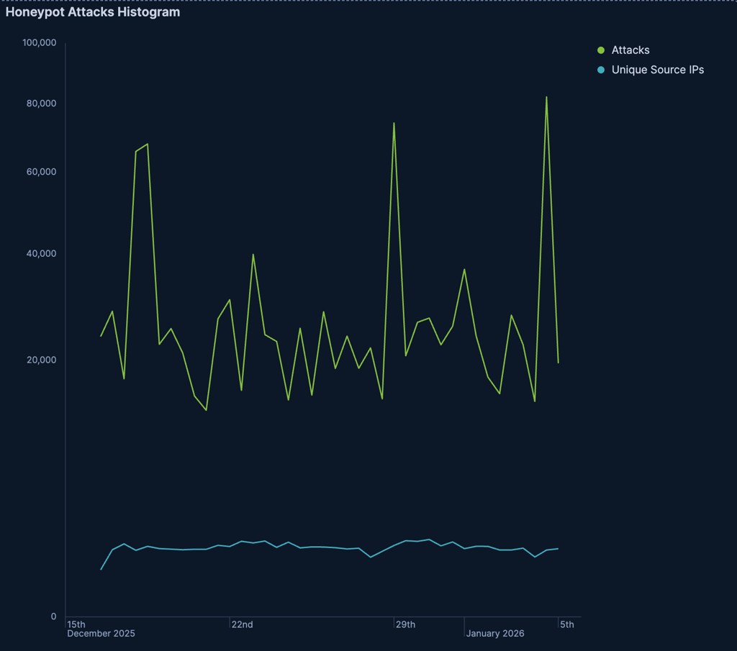
Figure 2 disaggregates attack frequency by honeypot type across the observation period, revealing distinct attack patterns across different honeypot services.  Honeytrap was responsible for the dramatic December 17th-18th spike, reaching approximately 52,000 attacks, suggesting a surge in network service probing consistent with the broader global threat activity observed mid-December 2025. Dionaea dominated the December 29th spike alongside a contribution from Heralding, indicating that Windows service exploitation attempts and credential-based attacks occurred in tandem during the holiday window, consistent with the reduced defensive posture typical of the Christmas period.  The January 4th-5th period is particularly notable as it produced two distinct and simultaneous attack surges from different honeypots. Dionaea experienced its largest spike of the observation period at approximately 65,000 attacks, while Cowrie independently spiked to its own peak; the two occurring in parallel but likely representing separate threat campaigns. The Dionaea surge suggests a wave of Windows service exploitation attempts, while the isolated Cowrie spike points to a targeted SSH brute force or credential stuffing campaign, potentially leveraging fresh credential lists commonly circulated around the new year. The independence of these two spikes suggests distinct threat actors or automated campaigns operating simultaneously rather than a single coordinated attack.  Tanner remained consistently low throughout the entire period, indicating minimal targeting of web application services. Cowrie otherwise maintained a moderate and gradually increasing baseline, suggesting sustained SSH scanning activity throughout the observation window. | 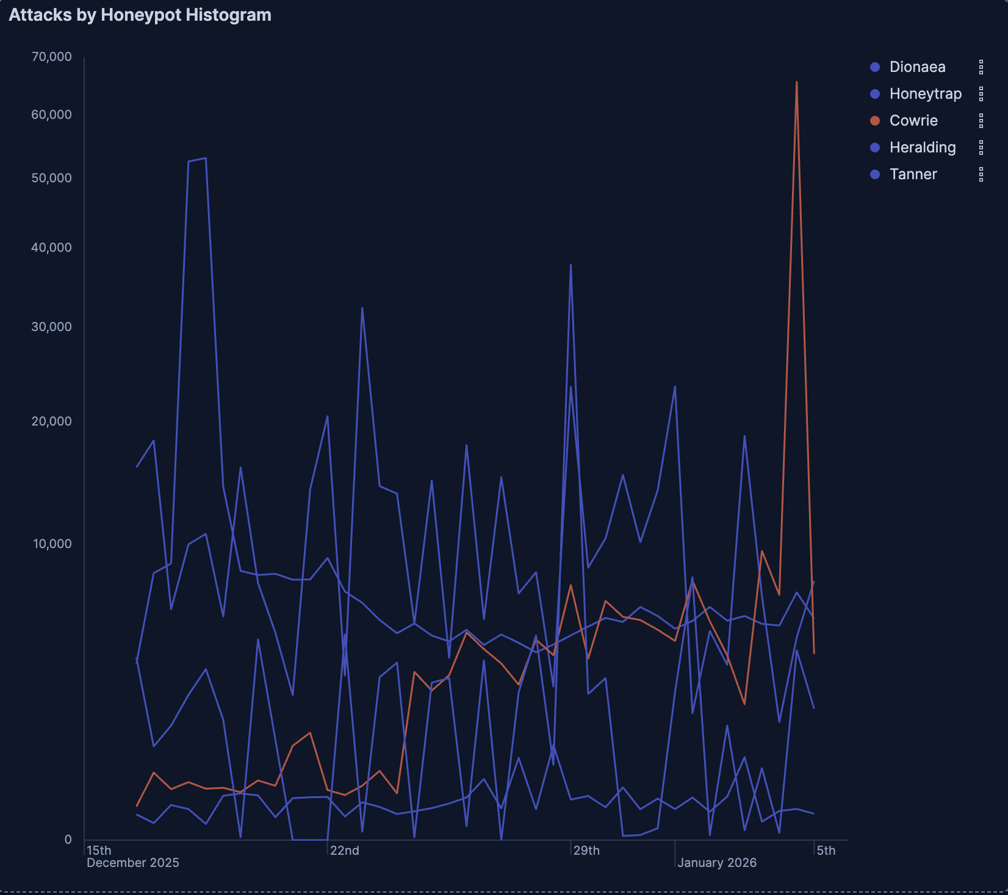
Figure 3 maps attack frequency by source country across the observation period, revealing distinct geographic patterns that closely correlate with the honeypot-specific spikes identified in Figure 2.  Indonesia emerged as the dominant attack source during the December 17th-18th spike, contributing approximately 45,000 attacks, closely mirroring the Honeytrap surge identified in Figure 2. This correlation suggests that the mid-December network service probing campaign originated predominantly from Indonesian infrastructure, whether through direct threat actor activity or compromised Indonesian systems participating in a broader botnet campaign.  The January 4th-5th period produced the most analytically significant geographic finding of the observation window. Canada emerged as the dominant attack source, spiking to approximately 60,000 attacks, which is the highest single-country volume recorded across the entire period. This is particularly notable given that Canada is not typically among the top sources of malicious internet traffic. Combined with the simultaneous Cowrie spike identified in Figure 2, this strongly suggests that the January SSH brute force campaign was proxied through compromised Canadian infrastructure, a common technique used by threat actors to obscure their true geographic origin. The United States maintained a consistently elevated baseline throughout the observation period, reflecting the high volume of US-based internet infrastructure rather than necessarily indicating direct threat actor activity.  China and Vietnam appeared sporadically throughout the period but did not dominate any spike, suggesting opportunistic scanning activity rather than coordinated campaigns. | 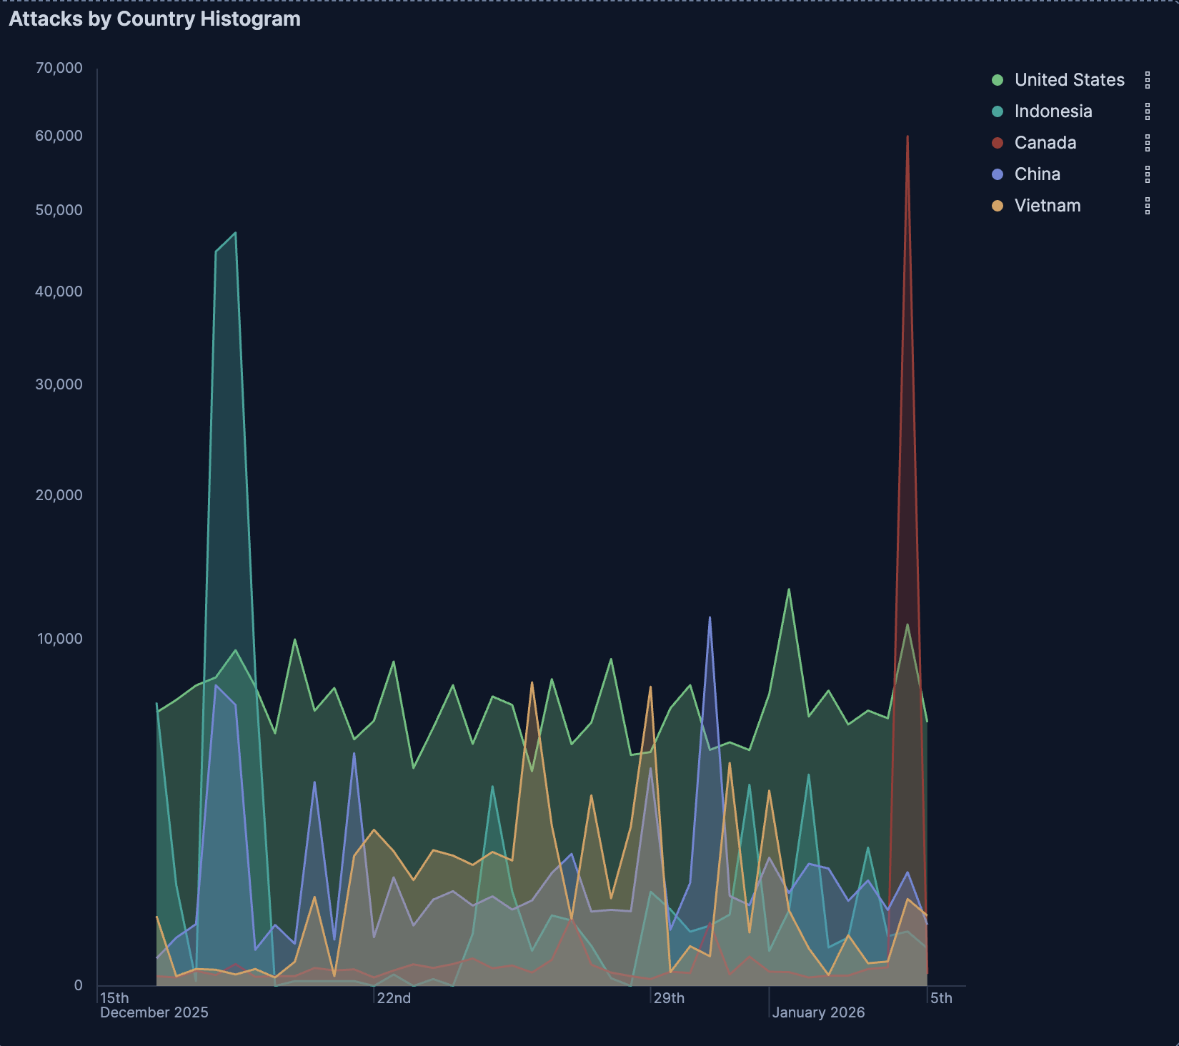
Figure 4 maps attack frequency by destination port, providing protocol-level insight into attacker intent across the observation period and further corroborating the patterns identified in Figures 2 and 3.  Port 445 (SMB) dominated attack volume consistently throughout the entire observation window, reflecting persistent and automated scanning for Windows file sharing vulnerabilities. This sustained targeting is consistent with the Dionaea honeypot's elevated baseline observed in Figure 2, confirming that SMB exploitation was the most pervasive attack vector across the period.  The December 29th spike reveals a particularly compelling finding. Port 5900 (VNC) surged dramatically to approximately 38,000 attacks, representing the highest single-port volume recorded on that date. VNC is a remote desktop access protocol, and the timing of this spike during the Christmas holiday window is highly significant. Attackers appear to have specifically targeted remote desktop access during a period when systems were likely unattended and security staffing was reduced, suggesting deliberate and opportunistic hunting for visual system control rather than automated scanning. This correlates strongly with the Dionaea and Heralding spikes identified in Figure 2, painting a picture of coordinated holiday-period intrusion attempts.  The January 4th-5th Port 22 (SSH) spike provides the final piece of the Canada-Cowrie correlation established across Figures 2 and 3. The simultaneous appearance of elevated SSH traffic, a Cowrie honeypot spike, and Canadian-proxied source traffic on the same dates strongly confirms that a targeted SSH brute force campaign was routed through compromised Canadian infrastructure at the start of the new year.  Perhaps the most anomalous finding in this figure is the spike in Port 5920 activity. Port 5920 is not a standard well-known service port, making its appearance in the attack data particularly suspicious. This could indicate custom malware command-and-control communication, a non-standard VNC variant deployment, or exploitation attempts targeting a niche or misconfigured service. This warrants further investigation and correlation against threat intelligence feeds to determine whether this port has been associated with known malware families or campaigns. | 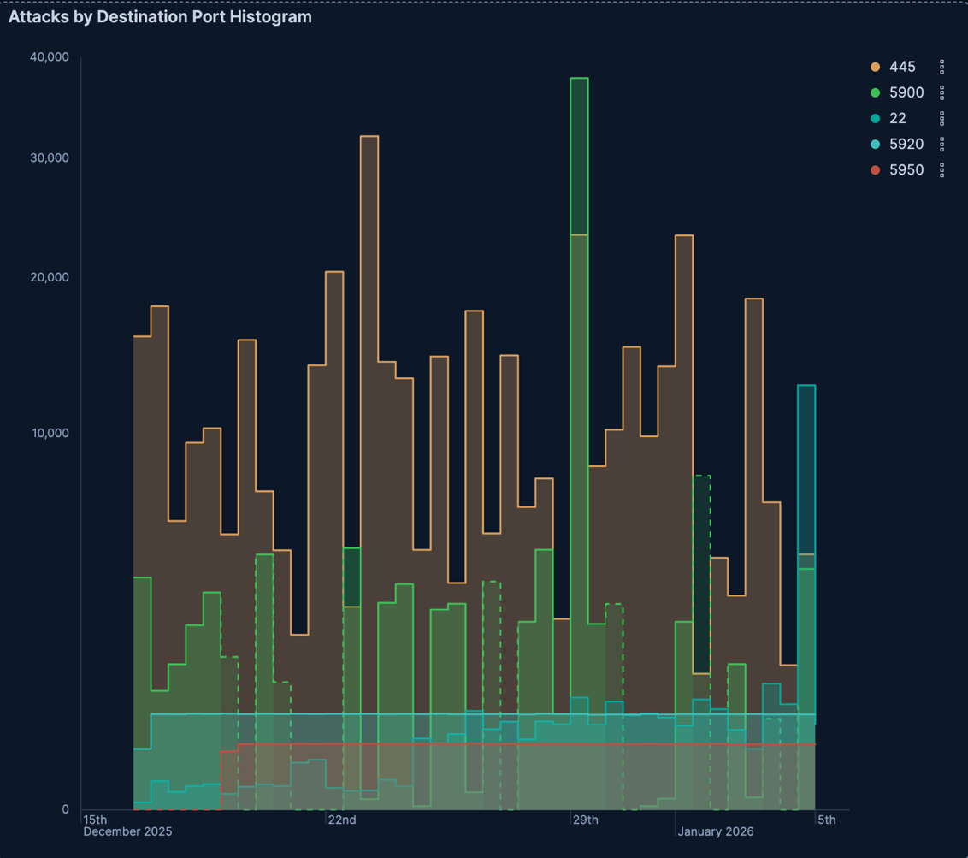
Figure 5 presents a dynamic geographic attack map visualizing the global distribution of attack origins across the observation period. The map corroborates and expands upon the country-level findings identified in Figure 3, while revealing additional geographic patterns not captured in the top-five country breakdown.  The most striking feature of the attack map is the intense concentration of attack activity originating from South America, represented by large red, yellow, and green bubbles indicating exceptionally high attack volumes. This finding is particularly notable given that South American countries did not appear prominently in Figure 3's top-five source countries, suggesting that while individual South American nations may fall outside the top five, their collective volume is substantial. Brazil, a well-documented source of global botnet traffic, is the likely primary contributor to this cluster. As with the Canadian spike identified in Figure 4, the intensity of South American activity may reflect compromised infrastructure being leveraged as proxies rather than direct threat actor origination.  North America displays large yellow and green bubbles consistent with the sustained US baseline and Canadian spike previously identified, while Southeast Asia shows moderate activity concentrated in Indonesia, corroborating the December 17th-18th findings from Figure 3. Europe exhibits widespread but relatively low-volume activity scattered across multiple countries, suggesting broad but diffuse opportunistic scanning rather than concentrated campaigns. Africa, the Middle East, and Oceania contribute sparse, low-volume activity throughout the period.  The global distribution of attack origins underscores a key finding of this observation period, malicious activity targeting the honeynet was not confined to a single region or threat actor, but rather reflected a diverse and geographically distributed threat landscape, with multiple simultaneous campaigns originating from different parts of the world. | 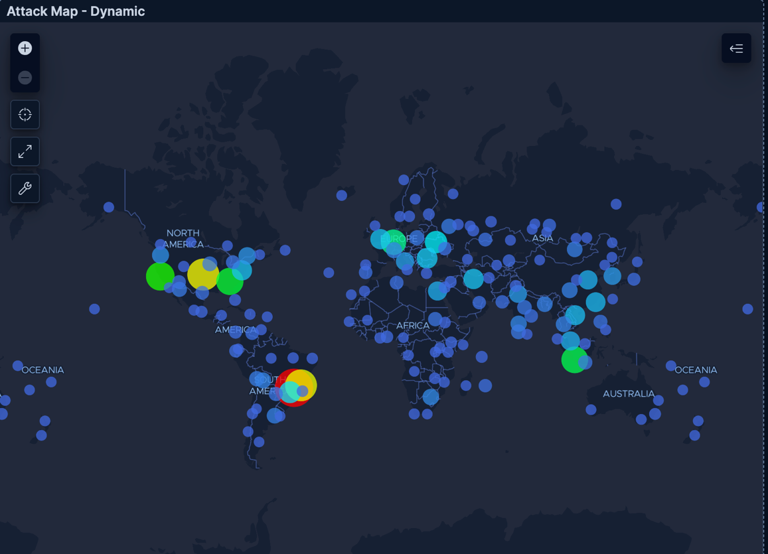
Figure 6 presents the aggregate distribution of attacks by source country across the entire observation period, providing a cumulative complement to the time-series patterns identified in Figure 3. While Figure 3 revealed temporal spike patterns, Figure 6 captures overall volume contribution, and the distinction between the two yields one of the most analytically significant findings of this observation period.  The United States dominates aggregate attack volume, accounting for approximately 35-40% of total attacks across the period. However, this must be interpreted carefully in the context of Figure 3. The US did not produce dramatic isolated spikes but rather maintained a consistently elevated baseline throughout the observation window. This pattern is characteristic of large-scale automated scanning originating from the vast US-based internet infrastructure, including cloud providers, hosting services, and compromised residential networks, rather than targeted campaigns.  Indonesia ranks second in aggregate volume, consistent with its dominant role in the December 17th-18th spike identified in Figure 3. Its significant overall share reflects both the intensity of that spike and a sustained moderate baseline throughout the period. Canada ranks third in aggregate volume despite being relatively quiet for most of the observation window, a testament to the sheer magnitude of the January 4th-5th SSH brute force spike, which was large enough to push Canada into the top three overall contributors. China, Vietnam, and India contributed moderate and relatively consistent volumes, suggesting opportunistic automated scanning rather than concentrated campaigns. Ukraine, Iran, Egypt, and South Korea each contributed smaller but notable shares, reflecting the truly global nature of the threat landscape observed.  The contrast between sustained baseline attackers such as the United States and burst campaign attackers such as Canada and Indonesia represents a key analytical finding. Different threat actors employ fundamentally different operational tempos, with some maintaining persistent low-level reconnaissance while others launch concentrated high-volume campaigns before going quiet. | 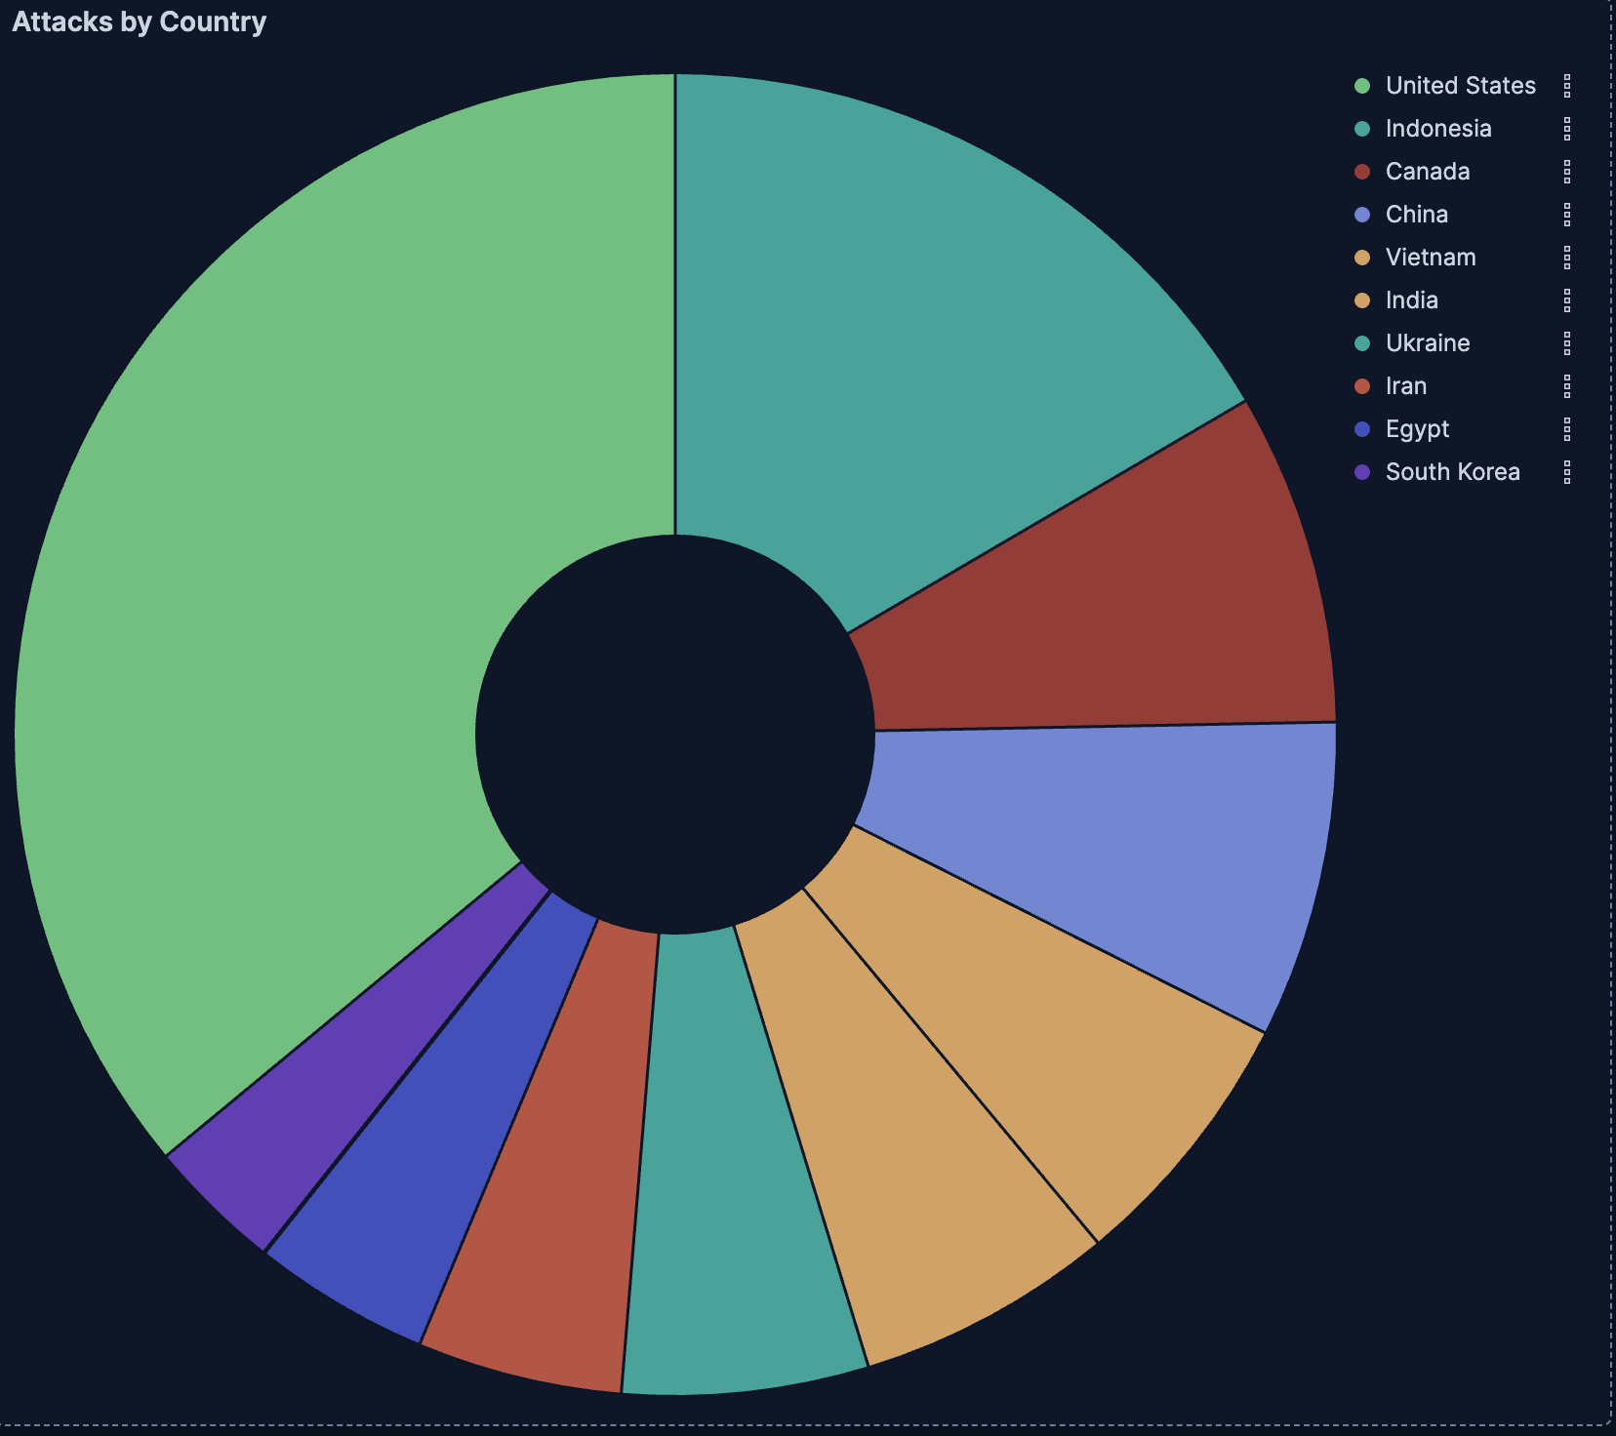
Figure 7 disaggregates attack traffic by both source country and destination port, revealing striking differences in the attack profiles of each major contributing nation and providing critical insight into the sophistication and intent of attacks originating from different geographic regions.  Indonesia's attack profile is overwhelmingly concentrated on Port 445 (SMB), accounting for approximately 95% of its total attack volume. This extreme single-port focus is characteristic of automated botnet scanning tools running simple, repetitive SMB exploitation scripts with little variation, suggesting that Indonesian-origin attacks during this period were largely unsophisticated and automated in nature. China and Italy exhibit nearly identical profiles, with Port 445 dominating their respective attack distributions, further supporting the conclusion that SMB-focused automated scanning is a globally prevalent but relatively indiscriminate attack pattern.  The United States presents a strikingly different profile — its attack distribution is the most diverse of all observed nations, spanning VNC (Port 5900), SSH (Port 22), SMB (Port 445), and several additional ports. This multi-vector approach suggests that US-based attack infrastructure, likely comprising large distributed botnets and compromised cloud servers, is being leveraged for more varied and sophisticated scanning campaigns simultaneously targeting multiple service types. The significant VNC component in US-origin traffic is particularly notable and corroborates the December 29th VNC spike identified in Figure 4, suggesting that remote desktop access hunting was disproportionately driven by US-based infrastructure.  South Korea presents perhaps the most distinctive profile, with a significant proportion of attacks targeting Port 23 (Telnet) alongside VNC and SMB. Telnet is a legacy protocol largely deprecated in favor of SSH due to its transmission of credentials in plaintext, and its targeting suggests either exploitation of older unpatched systems or deliberate hunting for legacy infrastructure. This is an anomalous finding that warrants further investigation.  Collectively, Figure 7 reveals that attack sophistication and diversity vary significantly by country of origin, with US-based infrastructure demonstrating the broadest and most varied attack surface coverage while Indonesia, China, and Italy operate predominantly as single-purpose SMB scanning sources. | 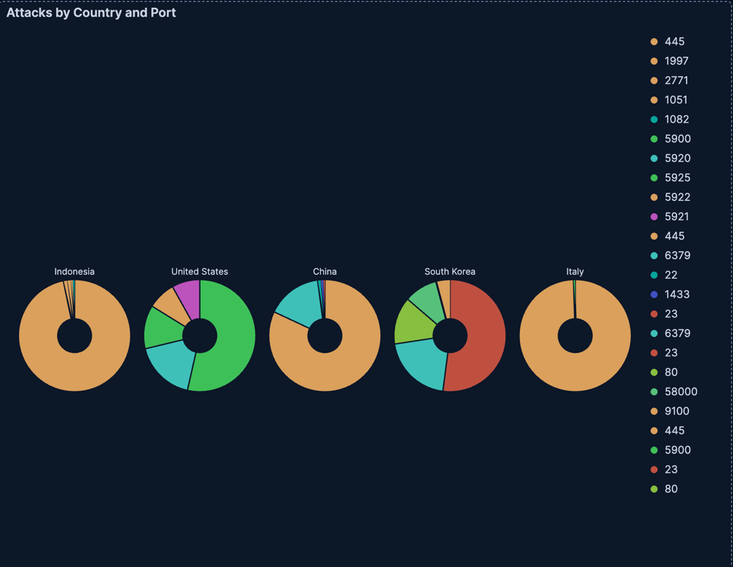
Figure 8 presents the reputation distribution of attacking source IPs across the observation period. Known attackers (IPs previously flagged in threat intelligence databases) account for approximately 80-85% of all attack traffic, with mass scanners comprising the remaining ~15% and bots, crawlers, Tor exit nodes, and form spammers contributing negligible volumes.  Notably, this distribution is consistent with ratios observed in previous observation periods, suggesting that despite the dramatic volumetric spikes identified throughout this report, the fundamental composition of the threat landscape remained stable. The holiday period did not attract novel or previously unknown threat actors but rather, existing known bad actors simply increased their operational tempo during periods of reduced defensive coverage.  This finding carries significant defensive implications. The dominance of already-flagged source IPs suggests that organizations with well-maintained threat intelligence feeds and proactive IP blocklists could have automatically blocked the majority of observed attack traffic before it reached critical infrastructure. The consistency of this ratio across observation periods further validates the reliability and representativeness of the honeynet data as a threat intelligence source. | 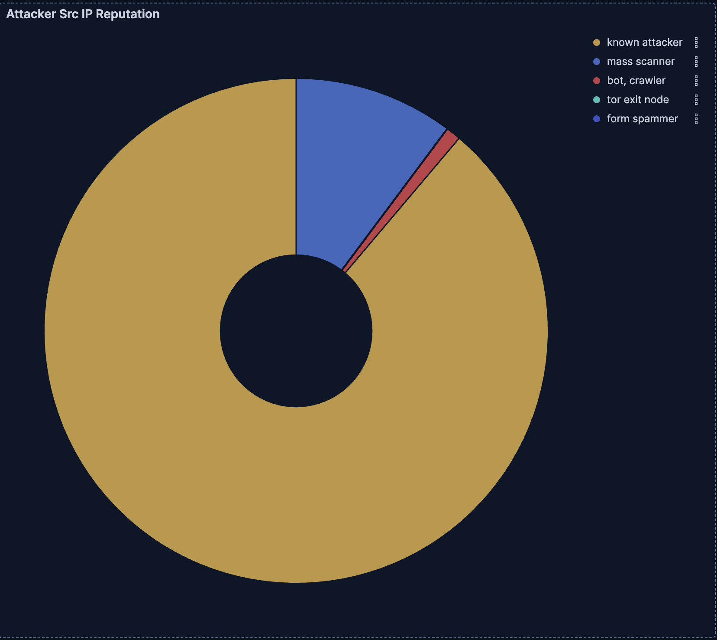
Figure 9 presents Suricata IDS alert categories across the observation period, adding a critical layer of behavioral intent analysis to the volumetric patterns identified in previous figures. While earlier figures quantified attack frequency and origin, Suricata alert data reveals what attackers were actually attempting to accomplish.  Miscellaneous Activity dominates as a consistent baseline throughout the entire observation window, representing background noise level network activity flagged by Suricata but not necessarily indicative of targeted malicious intent. Miscellaneous Attack alerts form a steady secondary baseline, reflecting the persistent automated scanning activity corroborated across Figures 2 through 7.  The most significant finding in this figure is the dramatic spike in Attempted Administrator Privilege Gain alerts on December 17th, coinciding precisely with the Honeytrap volumetric spike identified in Figure 2, the Indonesian attack surge from Figure 3, and the multi-port activity observed in Figure 4. This correlation is analytically critical and it elevates the December 17th-18th event from a simple volumetric anomaly to a confirmed active exploitation attempt. Attackers during this period were not merely scanning or probing but were actively attempting to escalate privileges on compromised systems, suggesting a more sophisticated and targeted campaign than the automated SMB scanning typical of Indonesian-origin traffic. A secondary Attempted Administrator Privilege Gain spike is also observed on December 22nd, indicating that this threat actor or campaign persisted beyond the initial December 17th surge.  Generic Protocol Command Decode alerts spike alongside the privilege escalation attempts on December 17th, suggesting that attackers were employing protocol-level command injection techniques as part of their escalation methodology. Potentially Bad Traffic alerts appear sporadically throughout the period but do not correlate strongly with any single spike event, suggesting they reflect diffuse opportunistic activity rather than coordinated campaigns. | 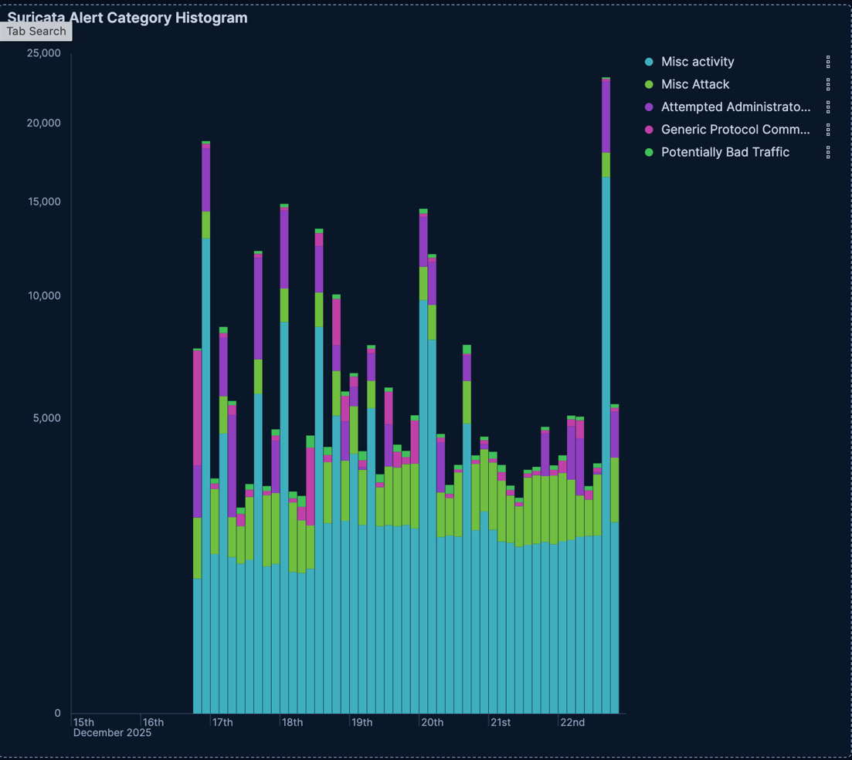
The findings from the username and password tag cloud are quite consistent with previous weeks’ findings. Threat actors generally try to exploit privileged and common accounts like admin, user, and even guest. They also supplement it with common default passwords, weakly secured passwords, or no password at all. This behavior is very consistent with credential stuffing. | 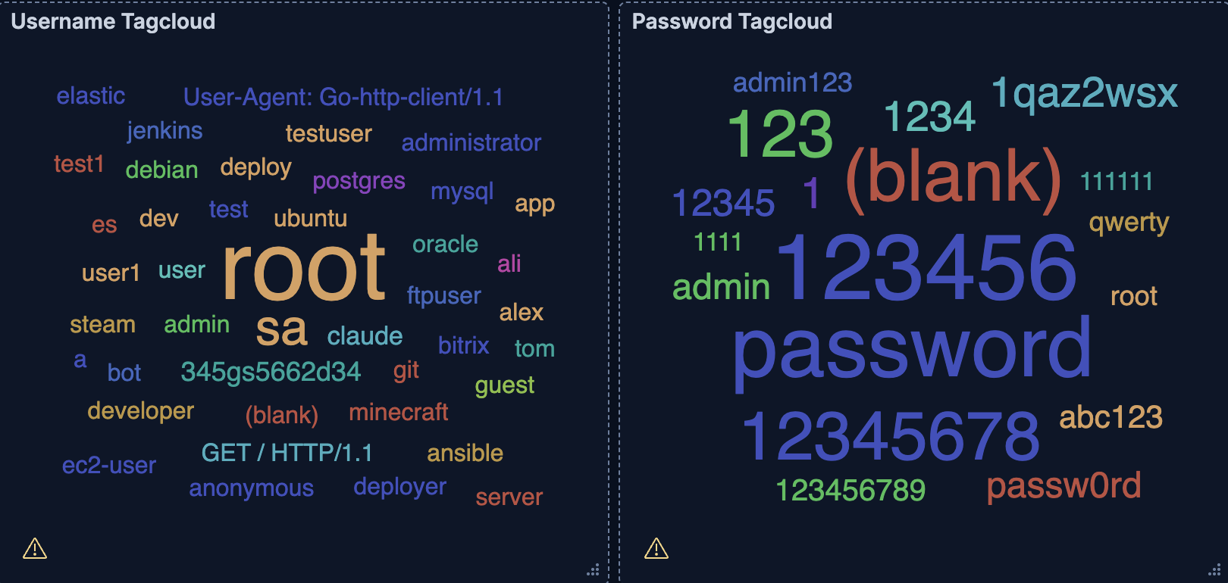
The Suricata CVE data reveals that legacy vulnerabilities dominate attack activity, with the top ten CVEs spanning over two decades of unpatched infrastructure.  CVE-2006-2369 (114,571 detections) — A RealVNC authentication bypass vulnerability from 2006 that allows remote attackers to completely bypass authentication without any credentials by specifying an insecure security type. Its overwhelming dominance directly corroborates the VNC Port 5900 spike identified in Figure 4 and the US-origin multi-vector attack profile in Figure 7 — attackers were not merely scanning for VNC services but actively exploiting a nearly 20-year-old vulnerability still present on unpatched internet-facing systems.  CVE-2025-55182 (723 detections) — "React2Shell," a critical pre-authentication remote code execution vulnerability in React Server Components and Next.js disclosed in December 2025. Its appearance so shortly after disclosure reflects the speed at which modern threat actors operationalize newly published vulnerabilities, consistent with the broader December threat activity identified in Figure 1.  CVE-2021-3449 (227 detections) — An OpenSSL denial-of-service vulnerability, consistent with the sustained SSH and TLS traffic observed throughout the period in Figures 2 and 4.  CVE-2019-11500 (211 detections) — A Dovecot mail server vulnerability enabling remote code execution via malformed input, suggesting attackers were scanning for exposed mail server infrastructure alongside their primary targets.  CVE-2002-0013 & CVE-2002-0012 (145 detections) — Over two-decade-old SNMP vulnerabilities, reflecting automated scanning tools that maintain exploit libraries stretching back to the earliest days of internet security research. Their presence confirms that attackers are opportunistically probing for any unpatched system regardless of patch age.  CVE-2002-1149 (114 detections) — Another 2002-era vulnerability, further reinforcing the legacy exploitation theme.  CVE-2024-4577 (65 detections) — A PHP-CGI argument injection vulnerability enabling remote code execution, consistent with the web application scanning activity suggested by Tanner honeypot traffic.  CVE-2023-46604 (64 detections) — A critical Apache ActiveMQ remote code execution vulnerability actively leveraged in ransomware campaigns since 2023, suggesting that ransomware-affiliated threat actors were among those probing the honeynet during this period.  CVE-2021-41773 (34 detections) — An Apache HTTP Server path traversal vulnerability enabling remote code execution on unpatched systems, again consistent with web-facing service exploitation attempts.  The temporal distribution of these CVEs — spanning from 2002 to 2025 — underscores a critical finding: attackers do not exclusively target cutting-edge vulnerabilities. Rather, they maintain active exploitation toolkits across multiple decades, scanning opportunistically for any unpatched system. Organizations that delay patching even well-known legacy vulnerabilities remain highly exposed, as evidenced by the 114,571 detections of a vulnerability disclosed and patched nearly 20 years ago. | 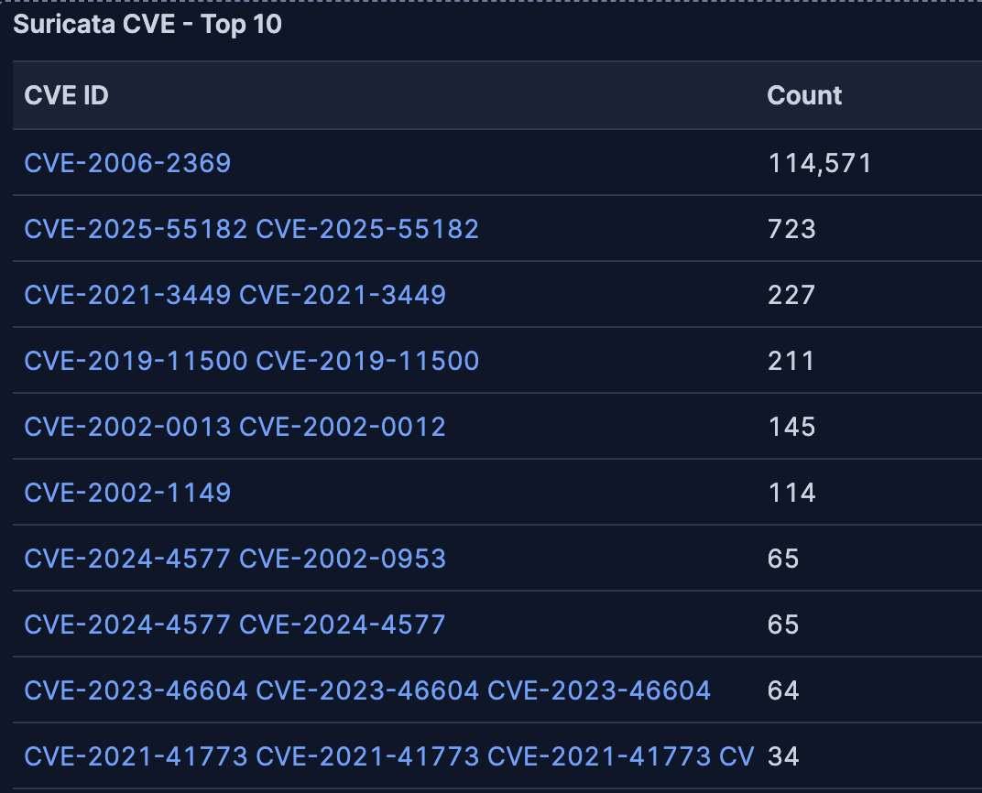
Figure 12 presents the top ten Suricata alert signatures, providing the most granular behavioral picture of attacker activity across the observation period and directly corroborating findings across all previous figures.  VNC-related signatures dominate the top three entries. GPL INFO VNC Server Response leads with 128,621 detections, confirming that VNC services were the most actively probed attack surface across the entire period. ET EXPLOIT VNC Server Not Requiring Authentication follows with 24,786 detections, directly corroborating CVE-2006-2369 from Figure 11, confirming that attackers successfully identified VNC servers with no authentication enabled. ET INFO VNC Authentication Failure accounts for 24,771 detections, indicating that while some VNC servers did require authentication, attackers persistently attempted to bypass it regardless. Attackers scanned for VNC services, found unprotected ones, and repeatedly attempted to breach protected ones.  The fourth entry is perhaps the most alarming finding in the entire dataset. ET EXPLOIT DoublePulsar Backdoor Installation Communication was detected 21,858 times. DoublePulsar is a backdoor implant tool developed by the NSA's Equation Group that was leaked by the Shadow Brokers in early 2017, and was used alongside EternalBlue in the May 2017 WannaCry ransomware attack. WannaCry targeted computers running Microsoft Windows by encrypting data and demanding ransom payments in Bitcoin, propagating itself using EternalBlue to gain access and DoublePulsar to install and execute copies of itself. The detection of DoublePulsar backdoor communication in the honeynet data directly corroborates the sustained Port 445 SMB dominance identified in Figure 4 and the Dionaea honeypot activity in Figure 2 — attackers were not merely scanning for SMB vulnerabilities but were actively attempting to install a kernel-level backdoor with full system control capabilities. DoublePulsar runs in kernel mode, granting cybercriminals a high level of control over the compromised system.  ET DROP Dshield Block Listed Source Group 1 accounts for 17,353 detections, directly corroborating the 80-85% known attacker IP reputation finding from Figure 8. These are source IPs already flagged in widely distributed threat intelligence blocklists, confirming that proactive IP blocking would have mitigated a significant portion of observed traffic.  ET SCAN NMAP -sS Window 1024 with 5,165 detections confirms active network reconnaissance using one of the most widely used port scanning tools, consistent with the mass scanner IP reputation category from Figure 8. The three Suricata Stream anomaly signatures (excessive different SYN/ACKs, broken ACKs, and spurious retransmissions) collectively account for over 10,000 detections and indicate deliberate TCP stack manipulation, suggesting that a subset of attackers employed packet-level evasion techniques to avoid detection by traditional security controls.  ET INFO Reserved Internal IP Traffic with 4,037 detections suggests that some attacking infrastructure was routing traffic through internal or reserved IP ranges, a technique commonly associated with network spoofing or compromised internal relay nodes, further supporting the proxied infrastructure hypothesis established in Figures 3 and 4.  Collectively, the Suricata alert signatures confirm that the honeynet captured a rich and diverse set of real-world attack behaviors from unauthenticated VNC exploitation and NSA-grade backdoor installation attempts to active reconnaissance and sophisticated packet-level evasion representing a comprehensive cross-section of the modern threat landscape. | 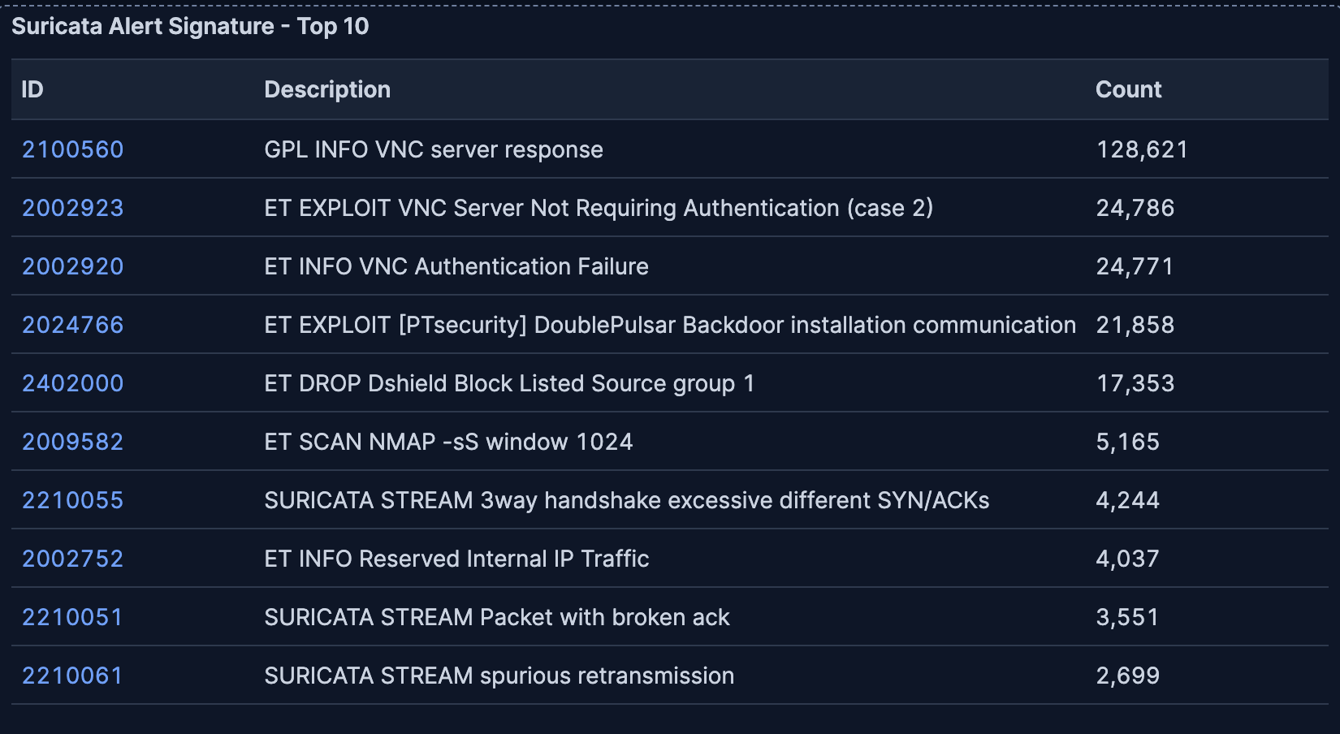
Figure 13 presents the top ten Autonomous System Numbers associated with attacking infrastructure, revealing the network providers and hosting services behind the observed attack traffic and providing the final layer of corroboration for the geographic and behavioral findings established throughout this report.  FUTURE-LAIN dominates with 94,152 attack connections. After looking up the ASN, I found that FUTURE-LAIN is an Indonesian ISP, directly and definitively corroborating the Indonesian attack surge identified in Figures 3 and 6 and confirming that the December 17th-18th Honeytrap spike was predominantly sourced from Indonesian consumer and business internet infrastructure.  DigitalOcean appears second with 39,652 detections, representing one of the most analytically significant findings in this figure. DigitalOcean is a legitimate commercial cloud provider, and its prominence in the ASN data confirms that attackers are actively spinning up low-cost virtual private servers on commercial cloud platforms to conduct attack campaigns. This is a well-documented threat actor technique. Cloud infrastructure is cheap, scalable, and provides a degree of geographic and identity obfuscation. Its presence here directly supports the proxied and compromised infrastructure hypothesis established in Figures 3 and 4.  DYNU with 24,261 detections is a dynamic DNS provider, whose presence in the top three further corroborates the infrastructure obfuscation theme — attackers commonly abuse dynamic DNS services to rapidly rotate and mask the true origin of their attack infrastructure, making attribution and blocking significantly more difficult.  LG DACOM Corporation with 19,617 detections is a major South Korean ISP, directly corroborating the South Korean attack profile identified in Figure 7, where Telnet and mixed-port targeting was observed. Chinanet with 14,743 detections is China's state-owned telecommunications backbone, consistent with China's moderate but persistent presence across Figures 3, 6, and 7. TIM with 11,046 detections is Italy's national telecommunications provider, directly corroborating Italy's single-purpose SMB scanning profile from Figure 7 and confirming that Italian consumer internet infrastructure was a significant source of automated Port 445 scanning.  Perhaps most notably, AMAZON-02 appears in the top ten with 8,057 detections, joining DigitalOcean as a second major legitimate cloud provider whose infrastructure was abused for attack traffic. The combined presence of both DigitalOcean and AWS in the top ten ASNs illustrates how commercial cloud infrastructure has become a preferred launchpad for cyberattacks due to its accessibility, scalability, and the inherent difficulty of distinguishing malicious cloud traffic from legitimate cloud traffic. | 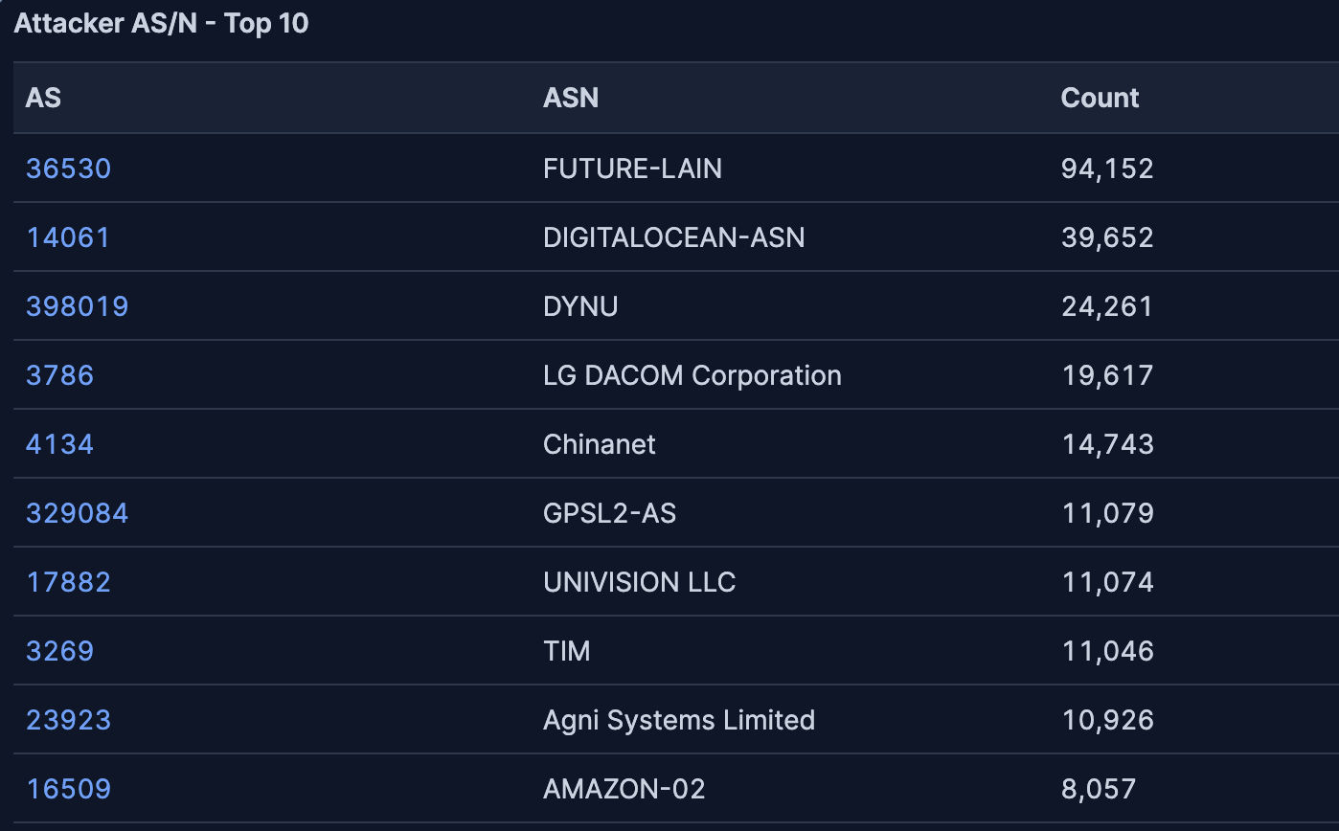
The top three IPs alone account for a disproportionate share of total observed connections, suggesting that blocking a relatively small number of source addresses would have dramatically reduced overall attack traffic — a finding that reinforces the practical value of real-time threat intelligence feeds and automated IP blocklisting as defensive measures.  Cross-referencing with Figure 13, several of these top IPs are likely hosted on the ASNs identified previously, particularly FUTURE-LAIN, DigitalOcean, and DYNU, consistent with the Indonesian ISP dominance and commercial cloud infrastructure abuse patterns established throughout this report. The presence of IPs from DYNU's dynamic DNS infrastructure among the top attackers further supports the infrastructure obfuscation hypothesis, as dynamic DNS allows attackers to rapidly rotate addresses while maintaining persistent attack campaigns. | 